Little Sistahs in the Know, Inc
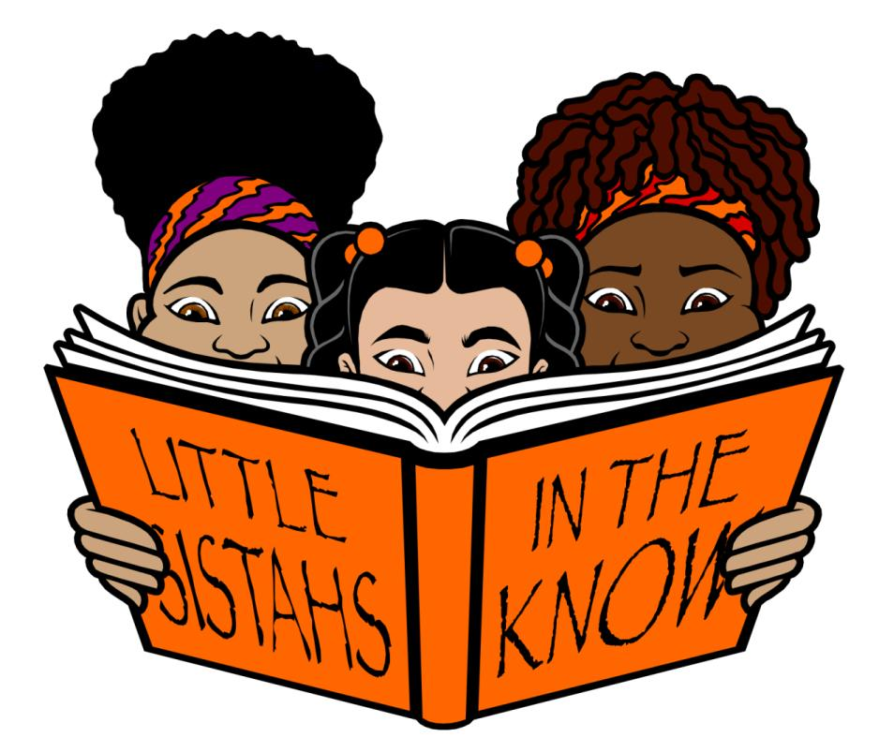
P O Box 6833, Monroe Twp., NJ 08831

Photograph Image Waiver

Girl’s Name(s)

Address (City, State & Zip): Home Phone: Cell Phone: Email Address:

I, ___________________, parent/guardian of the above listed minor child(ren) hereby give permission to Little Sistahs in the Know, Inc. of P.O. Box 6833, Monroe Twp, NJ 08831 and/or parties designated by Little Sistahs in the Know, Inc., to use photographs of said minor child in all forms of media, for any and all promotional purposes of Little Sistahs in the Know, Inc. including advertising, publicity, display, audiovisual, exhibition, commercial, editorial, or website use. Only the said minor child’s photograph will be used and no identification of the said minor child, any whatsoever, will be attached to the photograph.

I understand that the term “photograph” as used herein encompasses still photographs, audio recordings, and video footage.

I further consent to the reproduction and/or authorization by Little Sistahs in the Know, Inc. to reproduce and use such photographs for use in all domestic and foreign markets.

I understand that the photographs will be the sole property of Little Sistahs in the Know, Inc. or its affiliate chapters.

I hereby release Little Sistahs in the Know, Inc. and any of its associates, affiliates, appointed advertising agencies, designated directors, officers, agents, volunteers, employees, and customers from any claims.

This waiver remains in effect until withdrawn by the parent/guardian of the children listed above. Withdrawal requests must be made in writing to the national office.

Parent/Guardian (Signature/Initials): ___________________________ Date: ______________________

